LAB 5
Task 1:
#include <iostream>
using namespace std;

bool palindrome(const string& s, int left, int right)
{
if(left>=right)
{
return true;
}
if(s[left]!=s[right])
{
return false;
}
return palindrome(s, left+1, right-1);
}

int main()
{
string s;
cout << "Enter a string: ";
cin >> s;
int length=s.size()-1;
if(palindrome(s,0,length))
{
cout << s << " is a palindrome string" << endl;
}
else
{
cout << s << " is not a palindrome string" << endl;
}
}
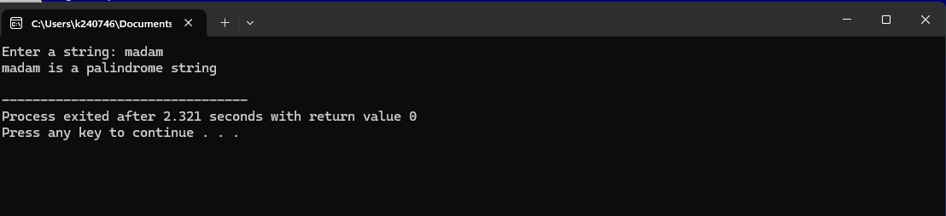
Task 2:
#include <iostream>
using namespace std;

int gcd(int n1, int n2)
{
if(n2==0)
return n1;
return gcd(n2,n1%n2);
}

int main()
{
int n1,n2;
cout << "Enter number 1: ";
cin >> n1;
cout << "Enter number 2: ";
cin >> n2;
cout << "GCD of " << n1 << " and " << n2 << " is: " << gcd(n1,n2) << endl;
}
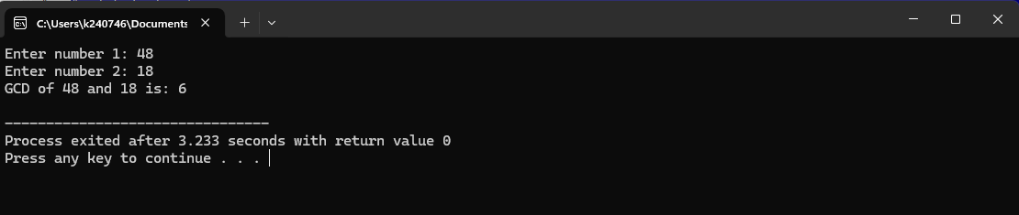
Task 3:
#include <iostream>
using namespace std;

struct File
{
int size;
};

struct Folder
{
File files[10];
int fileCount;

Folder* subfolders[10];
int subfolderCount;

Folder()
{
fileCount = 0;
subfolderCount = 0;
for (int i = 0; i < 10; i++)
subfolders[i] = NULL;
}
};

int getFolderSize(Folder* folder)
{
int totalSize = 0;

for (int i = 0; i < folder->fileCount; i++)
{
totalSize += folder->files[i].size;
}

for (int i = 0; i < folder->subfolderCount; i++)
{
totalSize += getFolderSize(folder->subfolders[i]);
}

return totalSize;
}

int main()
{
Folder root;

root.files[0].size = 100;
root.files[1].size = 200;
root.fileCount = 2;

Folder sub1;
sub1.files[0].size = 50;
sub1.fileCount = 1;

Folder sub2;
sub2.files[0].size = 300;
sub2.files[1].size = 150;
sub2.fileCount = 2;

root.subfolders[0] = &sub1;
root.subfolders[1] = &sub2;
root.subfolderCount = 2;

cout << "Total size of root folder: " << getFolderSize(&root) << " KB" << endl;

return 0;
}
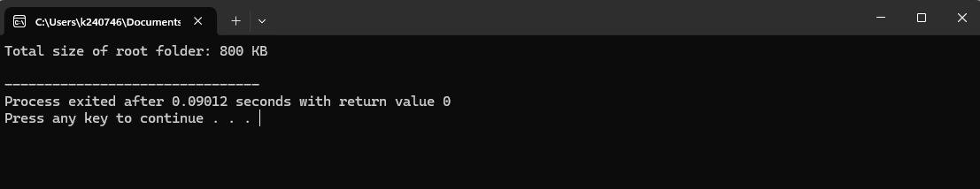
Explanation:
- Used fixed-size arrays to store files and subfolders.
- Each folder can hold up to 10 files and 10 subfolders.
- getFolderSize() recursively sums file sizes and subfolder sizes.
- In main(), we manually create folders and files and link subfolders through pointers.

